**Polymorphism** literally means taking more than one form.

Polymorphism is a characteristic of being able to assign a different behavior or value in a subclass, to something that was declared in a parent class.

Polymorphism means—One name many form. It is **2 types: 1) Compile time: Overloading. 2) Run time: Overriding.**

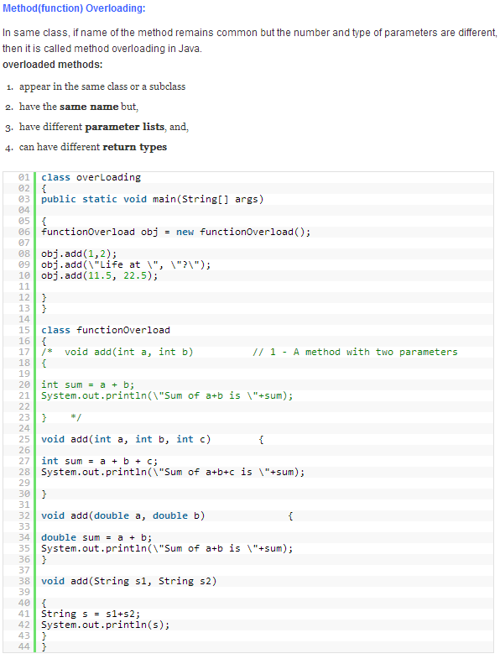

**Constructor Overloading:**

* Constructor overloading is a technique in Java in which a class can have any number of constructors that differ in parameter lists.
* The compiler differentiates these constructors by taking into account the number of parameters in the list and their type.

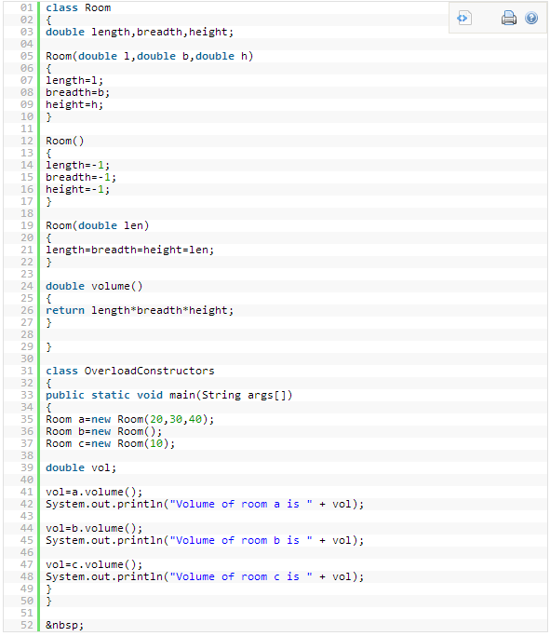

**Overriding:**

* applies **ONLY** to inherited methods          is related to polymorphism
* object type (**NOT** reference variable type) determines which overriden method will be used at runtime
* overriding method **MUST** have the same argument list (if not, it might be a case of overloading)
* overriding method **MUST** have the same return type; the exception is *covariant return* (used as of Java 5) which returns a type that is a subclass of what is returned by the overriden method
* overriding method **MUST NOT** have more restrictive access modifier, but **MAY** have less restrictive one
* overriding method **MUST NOT** throw new or broader checked exceptions, but **MAY** throw fewer or narrower checked exceptions or any unchecked exceptions
* abstract methods **MUST** be overridden
* final methods **CANNOT** be overridden
* static methods **CANNOT** be overridden
* constructors **CANNOT** be overridden

